What Is DevOps Lifecycle?

DevOps Lifecycle is a Methodology software development teams use to bring products to market more quickly and efficiently.
It's a way of managing the entire software lifecycle from development through release, focusing on collaboration between developers and IT operations professionals.
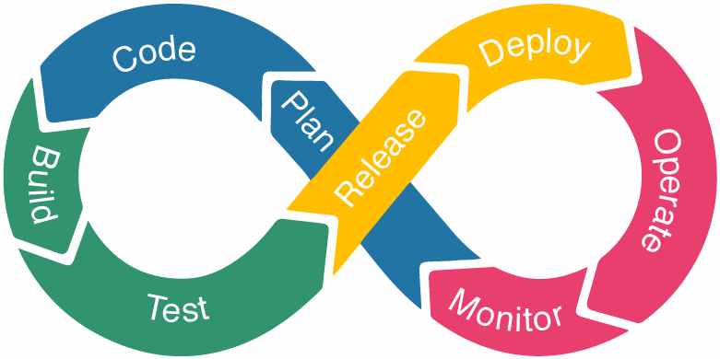

Let’s briefly overview how the DevOps lifecycle works at every stage.
- Plan: In this stage, teams identify the business requirement and collect end-user feedback. They create a project roadmap to maximize the business value and deliver the desired product during this stage. Tools : Google Doc, Draw.io

- Code: The Code development takes place at this stage. The development teams use some tools and plugins like Git to streamline the development process, which helps them avoid security flaws and lousy coding practices.
Tools : Git, Gitlab.

- Build: In this stage, once developers finish their task, they commit the code to the shared code repository using build tools.
Tools : Maven, Gradle.

- Test: Once the build is ready, it is deployed to the test environment first to perform several types of testing like user acceptance test, security test, integration testing, performance testing, etc., using tools like JUnit, Selenium, etc., to ensure software quality.
Tools : JUnit, Selenium.

- Release: The build is ready to deploy on the production environment at this phase. Once the build passes all tests, the operations team schedules the releases or deploys multiple releases to production, depending on the organizational needs.
Tools : Jenkins, Bamboo.

- Deploy: In this stage, Infrastructure-as-Code helps build the production environment and then releases the build with the help of different tools.
Tools : AWS, Docker.

- Operate: The release is live now to use by customers. The operations team at this stage takes care of server configuring and provisioning using tools like Chef.
Tools : Ansible, Chef, Puppet, Kuberenetes.

- Monitor: In this stage, the DevOps pipeline is monitored based on data collected from customer behavior, application performance, etc. Monitoring the entire environment helps teams find the bottlenecks impacting the development and operations teams’ productivity.
Tools : Datadog, Nagios.
